Section A
- Poly(butene) is a polymer. What monomer would be used to make poly(butene)?
Tick ( ) one box.
- Butane | 
- Butene
- Butanol

- Bromoethene molecules can be added together to make a polymer. What would this polymer be called?
Tick ( ) one box.
- poly(ethene)
- poly(bromoethane)
- poly(bromoethene)

- Describe what happens during addition polymerisation.

______________________________________________________________________________________________________________________________________________________________________________________________
_______________________________________________________________________________________________

- Poly(ethene) is made through addition polymerisation of ethene molecules.

- Complete the displayed formula for ethene.

C C

- Complete the displayed formula for a section of poly(ethene).

C C C C C C

Section B
- Polyvinyl chloride (PVC) is a non-biodegradable polymer. The displayed formula below shows a section of a PVC molecule.
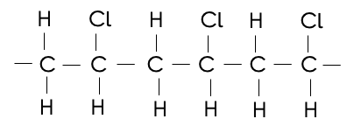

- Draw the displayed structure of the monomer used to make PVC.

- Explain why being non-biodegradable is a disadvantage of PVC.
_____________________________________________________________________________________________________________________________________________________________________________________________________________________________________________________________________________________________
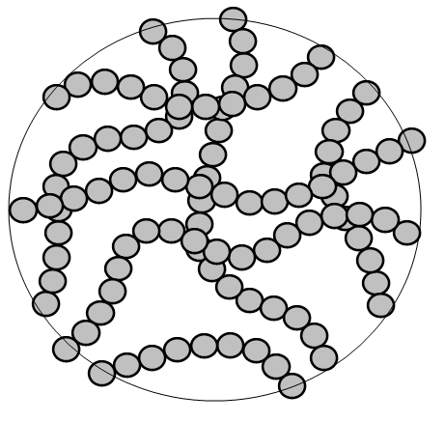
The diagram below represents some PVC molecules.

- Suggest whether PVC is likely to melt when heated.
____________________________________________________________________________________________________________________________________________________________________________________________________________________________________________________________________________________________________________________________________________________________________________________________

- Poly(chloroethene) and high-density polyethene (HDPE) are different polymers that can be used to make window frames. The table below gives some information about these polymers.

Polymer | HDPE | Poly(chloroethene)
Relative strength | 70 | 24
Density (g/cm³) | 1.5 | 0.9

- Use the table to give one advantage of using HDPE compared with poly(chloroethene) as a material for window frame.
Give a reason for your answer.

____________________________________________________________________________________________________________________________________________________________________________________________________________________________________________________________________________________________________________________________________________________________________________________________

- Use the table to give one advantage of using poly(chloroethene)compared with HDPE as a material for window frame.
Give a reason for your answer.

____________________________________________________________________________________________________________________________________________________________________________________________________________________________________________________________________________________________________________________________________________________________________________________________

- Polymers are used as an alternative material to wood for window frames.
Give one advantage and one disadvantage of using wood for window frames.

Advantage: ______________________________________________________________________________________________________________________________________________________________________________________________
Disadvantage: ______________________________________________________________________________________________________________________________________________________________________________________________

- HDPE is one form of poly(ethene). Explain how different forms of poly(ethene) can be produced from ethene.

_______________________________________________________________________________________________
_______________________________________________________________________________________________
_______________________________________________________________________________________________
Section C

- HDPE and LDPE are both types of poly(ethene) but they have different densities.
- Define density.
- HDPE has a density of 1.5 g/cm³. Calculate the volume that 1.5 kg of HDPE would occupy.
- Describe a method that could be used to calculate the density of an irregularly shaped piece of LDPE.

